MODULE 7 | QUALITY ASSURANCE AND DASHBOARD TESTING

EduVision 2026
Detailed QA, Testing and Release Report
Data validation, KPI reconciliation, semantic-model testing, dashboard verification, regression control and user acceptance evidence.
CONTROL POINT | VERIFIED RESULT
Executed QA checks | 300 / 300 passed
KPI reconciliation | 6 KPIs x 1,120 universities at 100% accuracy
Dashboard definition | 5 pages, 110 visuals and 310 active bindings
Release decision | APPROVED with 0 critical open defects

Prepared by Kamalesh Debnath | Final release date: 1 September 2026

Contents
- 1. Purpose, scope and release recommendation
- 2. Release candidate and test environment
- 3. QA governance, priorities and acceptance criteria
- 4. Test strategy and evidence architecture
- 5. Data-quality and integrity validation
- 6. KPI reconciliation and analytical accuracy
- 7. Semantic-model and portability testing
- 8. Dashboard functional testing by page
- 9. Filter, navigation and cross-interaction testing
- 10. Standard map testing
- 11. Compatibility, performance and reliability controls
- 12. Defect history and regression closure
- 13. User acceptance testing and sign-off
- 14. Risk assessment and release gate
- Appendices: test definitions, rerun instructions and evidence index

1. Purpose, Scope and Release Recommendation
Module 7 provides independent evidence that the EduVision release is accurate, complete, portable and suitable for academic submission and operational handover. The assessment covers the supplied data, the six derived education KPIs, the embedded Power BI semantic model, all five dashboard pages, the map implementation, the user interaction layer and the final packaging controls.
The validation does not rely only on visual inspection. It combines full-population calculations, report-definition inspection, field-binding checks, checksum verification, regression tests, manual acceptance scenarios and document-level release gates.
RELEASE RECOMMENDATION
APPROVED. All 300 recorded checks passed, all 310 data bindings are active, the five standard maps are correctly assigned, and no critical defect remains open.

2. Release Candidate and Test Environment
TEST DIMENSION | APPROVED RELEASE
Dashboard package | EduVision_PowerBI_Modules_4_to_6_Advanced_5_Dashboards_Standard_Maps_No_SignIn.zip
Release SHA-256 | 98dd2ed7bdae98fabe661d68af729c3cdb8c3f1d5ae097d94492813ba1593a12
University coverage | 1,120 universities across 93 countries and 5 regions
Time scope | Reporting year 2026 only
Power BI structure | 5 pages, 110 visuals, 95 data visuals, 35 DAX measures
Controls | 30 slicers, 22 KPI cards, 5 navigators and 5 standard maps
Binding state | 310 active projections and 0 inactive projections
Data mode | Embedded compressed Import model with no machine-specific path
Map dependency | Internet and the Map/Filled Map security setting; no Power BI sign-in

The structural tests execute against the extracted content of the approved release ZIP. Data tests execute against the raw, cleaned and final CSV files. KPI tests recalculate all six formulas from the cleaned dataset and compare every result with the final dataset. Manual UAT evidence is corroborated by the user's working Power BI file and the supplied screenshots.

3. QA Governance, Priorities and Acceptance Criteria
ROLE | RESPONSIBILITY
Project owner | Approves scope, accepts known limitations and authorizes release.
Data owner | Maintains the source workbook, country standardization and field definitions.
Model owner | Maintains DAX measures, embedded Import query and semantic-model schema.
QA owner | Runs the automated validator, regression suite, workbook checks and evidence review.
Power BI user | Performs first refresh, visual inspection, slicer/navigation UAT and PBIX save.
Reviewer | Reviews the final documentation, UAT sign-off and release manifest.

3.1 Priority and severity logic
- Critical tests protect record counts, KPI accuracy, active bindings, portability, page availability and release integrity. Any failure blocks release.
- High-priority tests protect page contracts, maps, controls, model measures and user workflows. A failure requires correction or explicit acceptance before release.
- Medium and low-priority items mainly concern usability, configuration guidance and residual operational constraints.

3.2 Acceptance gates
- Raw completeness must exceed 95%, cleaned missingness must remain below 2%, and duplicate institution-country-year keys must equal zero.
- All six KPIs must match for all 1,120 universities; the expected accuracy threshold is 100% for this verified reference build.
- The report must contain the five approved pages, 110 visuals, 22 KPI cards, 30 slicers, five navigators and five maps.
- All projections must be active, all visual field references must exist in the semantic model, and no Azure Map or cloud AI visual may remain.
- The model must be portable, with embedded Import data and no File.Contents machine path.
- The final handover must include the QA workbook, formal reports, operations guide, presentation, readout script and manifest.

4. Test Strategy and Evidence Architecture
TEST LAYER | METHOD | EVIDENCE
Release packaging | ZIP checksum, archive integrity and required-file checks | Release hash and package directory
Data quality | Full-dataset profile, completeness, missingness, duplicates and range tests | CSV files and audit JSON
KPI accuracy | Recalculate each KPI and compare 1,120 values | KPI reconciliation table
Semantic model | Parse TMDL measures, columns and partition expression | Universities.tmdl and validation summary
Dashboard structure | Parse every page.json and visual.json | Page and visual inventory
Visual bindings | Validate active projections and model field references | 310 projection checks
Maps | Validate visual type, roles, size measure, tooltips and page bounds | 35 map contract checks
UAT | Confirm rendered KPIs, charts, controls, maps and PBIX workflow | Power BI screenshots and user confirmation
Regression | Python unittest suite and historical-defect retests | test_milestone4.py and defect log

The final ledger contains 300 rows. Each row stores the requirement ID, test scenario, expected result, actual result, execution method, priority, status and evidence reference. The QA Master workbook provides the complete register and formula-driven traceability summary.

5. Data-Quality and Integrity Validation
QUALITY CONTROL | ACCEPTANCE | RESULT | STATUS
Raw records | 1,120 | 1120 | PASS
Raw source fields | 42 | 42 | PASS
Country coverage | 93 | 93 | PASS
Region coverage | 5 | 5 | PASS
Reporting year | 2026 only | 2026 | PASS
Source completeness | >95% | 98.176% | PASS
Cleaned missingness | <2% | 1.5686% | PASS
Duplicate keys | 0 | 0 | PASS
Final columns | 50 | 50 | PASS

5.1 Cleaning controls
- University names, countries and categorical fields are standardized while preserving all 1,120 records.
- QS and THE rank values are retained separately, then normalized independently on a 0 to 100 scale.
- No low-confidence institution match is created during Module 7. The validation consumes the verified source-stage and final datasets delivered by the earlier modules.
- Missing reported scores remain missing in source-level fields. The final KPI columns contain no missing values because the approved formulas define their required inputs and handling.
- The dataset remains a 2026 snapshot. No additional years or invented history are introduced for testing or presentation.

6. KPI Reconciliation and Analytical Accuracy
KPI | ROWS | MATCHING | ACCURACY | MAXIMUM DIFFERENCE
Global Ranking Score | 1,120 | 1,120 | 100.00% | 0.000000
Research Impact Score | 1,120 | 1,120 | 100.00% | 0.000000
Faculty to Student Ratio | 1,120 | 1,120 | 100.00% | 0.000000
International Student Percentage | 1,120 | 1,120 | 100.00% | 0.000000
Academic Reputation Score | 1,120 | 1,120 | 100.00% | 0.000000
Research Productivity Index | 1,120 | 1,120 | 100.00% | 0.000000

The reconciliation performs 6,720 direct row-KPI comparisons. All comparisons match within the strict numerical tolerance, producing a maximum absolute difference of zero for every KPI.

6.1 Formula control
KPI | AUDITABLE FORMULA | INTERPRETATION
Global Ranking Score | Average of normalized QS and THE ranks | Higher values indicate stronger combined ranking performance.
Research Impact Score | 35% citations + 45% research quality + 20% industry impact | Measures academic influence and practical impact.
Faculty-to-Student Ratio | 1 / students-to-staff ratio | Higher values represent greater faculty availability.
International Student Percentage | International student share x 100 | Reports international participation in percentage points.
Academic Reputation Score | Supplied academic-reputation score | Preserves the source value without transformation.
Research Productivity Index | 30% quality + 25% environment + 20% citations + 15% network + 10% industry | Weighted indicator proxy, not a publication-count measure.

RESEARCH LIMITATION
The source contains no publication-count field. The Research Productivity Index must always be described as a weighted performance proxy. The release contains no invented publication total.

7. Semantic-Model and Portability Testing
MODEL CONTROL | EXPECTED | OBSERVED
DAX measures | 35 | 35
Imported fields | 35 | 35
Active projections | 310 | 310
Inactive projections | 0 | 0
Import partition | Embedded | Binary.Decompress and Binary.FromText present
Machine path | Absent | No File.Contents path
External datasource objects | 0 | 0
Compatibility level | 1702 | 1702

The embedded Import design allows the PBIP project to load data without a machine-specific Excel path, gateway, credentials or Power BI sign-in. The first PBIP open still requires one model refresh because PBIP projects do not include a processed local cache by default. Saving as PBIX stores the refreshed model for normal future use.

8. Dashboard Functional Testing by Page
PAGE | VISUALS | DATA VISUALS | KPI | SLICERS | NAV | MAP | BINDINGS
University Overview | 21 | 18 | 4 | 6 | 1 | 1 | 56
Research Analytics | 21 | 18 | 4 | 6 | 1 | 1 | 59
Student Analytics | 21 | 18 | 4 | 6 | 1 | 1 | 58
Country Comparison | 21 | 18 | 4 | 6 | 1 | 1 | 59
Executive Command Center | 26 | 23 | 6 | 6 | 1 | 1 | 78

University Overview
The page contains 21 total report elements, 18 data visuals, 4 stable KPI cards, 6 dropdown slicers, one native page navigator and one standard map. It has 56 active query projections and zero inactive projections.
- KPI measures: Highest Global Score; Average Global Score; Country Count; University Count.
- Visual types: card (4), clusteredBarChart (1), clusteredColumnChart (1), donutChart (1), funnel (1), hundredPercentStackedBarChart (1), map (1), pageNavigator (1), pivotTable (1), slicer (6), textbox (2), waterfallChart (1).

Research Analytics
The page contains 21 total report elements, 18 data visuals, 4 stable KPI cards, 6 dropdown slicers, one native page navigator and one standard map. It has 59 active query projections and zero inactive projections.
- KPI measures: Average Citations per Faculty; Average Research Productivity; Average Research Quality; Average Research Impact.
- Visual types: card (4), clusteredBarChart (1), clusteredColumnChart (1), lineClusteredColumnComboChart (1), map (1), pageNavigator (1), pivotTable (1), ribbonChart (1), scatterChart (1), slicer (6), textbox (2), treemap (1).

Student Analytics
The page contains 21 total report elements, 18 data visuals, 4 stable KPI cards, 6 dropdown slicers, one native page navigator and one standard map. It has 58 active query projections and zero inactive projections.
- KPI measures: Average Student Population; Average Student Diversity; International Students %; Average Students to Staff.
- Visual types: card (4), clusteredBarChart (1), clusteredColumnChart (1), donutChart (1), gauge (1), map (1), pageNavigator (1), pivotTable (1), scatterChart (1), slicer (6), stackedAreaChart (1), textbox (2).

Country Comparison
The page contains 21 total report elements, 18 data visuals, 4 stable KPI cards, 6 dropdown slicers, one native page navigator and one standard map. It has 59 active query projections and zero inactive projections.
- KPI measures: Declined Universities; Country Count; Improved Universities; University Count.
- Visual types: card (4), clusteredBarChart (1), clusteredColumnChart (1), decompositionTreeVisual (1), map (1), pageNavigator (1), pieChart (1), pivotTable (2), slicer (6), textbox (2), waterfallChart (1).

Executive Command Center
The page contains 26 total report elements, 23 data visuals, 6 stable KPI cards, 6 dropdown slicers, one native page navigator and one standard map. It has 78 active query projections and zero inactive projections.
- KPI measures: Average Sustainability; University Count; Country Count; International Students %; Average Global Score; Average Research Impact.
- Visual types: card (6), decompositionTreeVisual (1), donutChart (1), funnel (1), gauge (1), hundredPercentStackedBarChart (1), lineClusteredColumnComboChart (1), map (1), pageNavigator (1), pivotTable (1), ribbonChart (1), scatterChart (1), slicer (6), textbox (2), treemap (1).
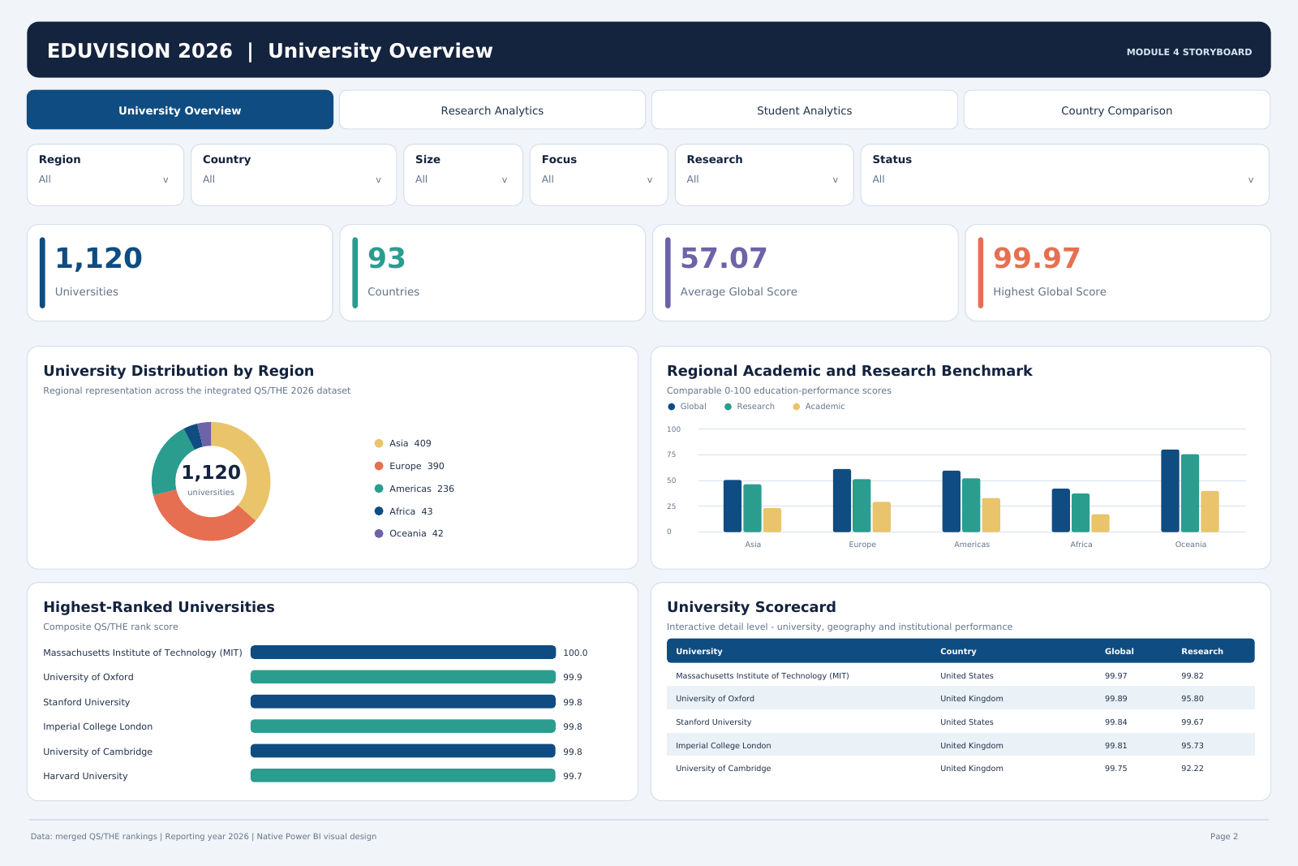
Figure 1. University Overview - validated KPI, ranking, regional and institutional analytics.
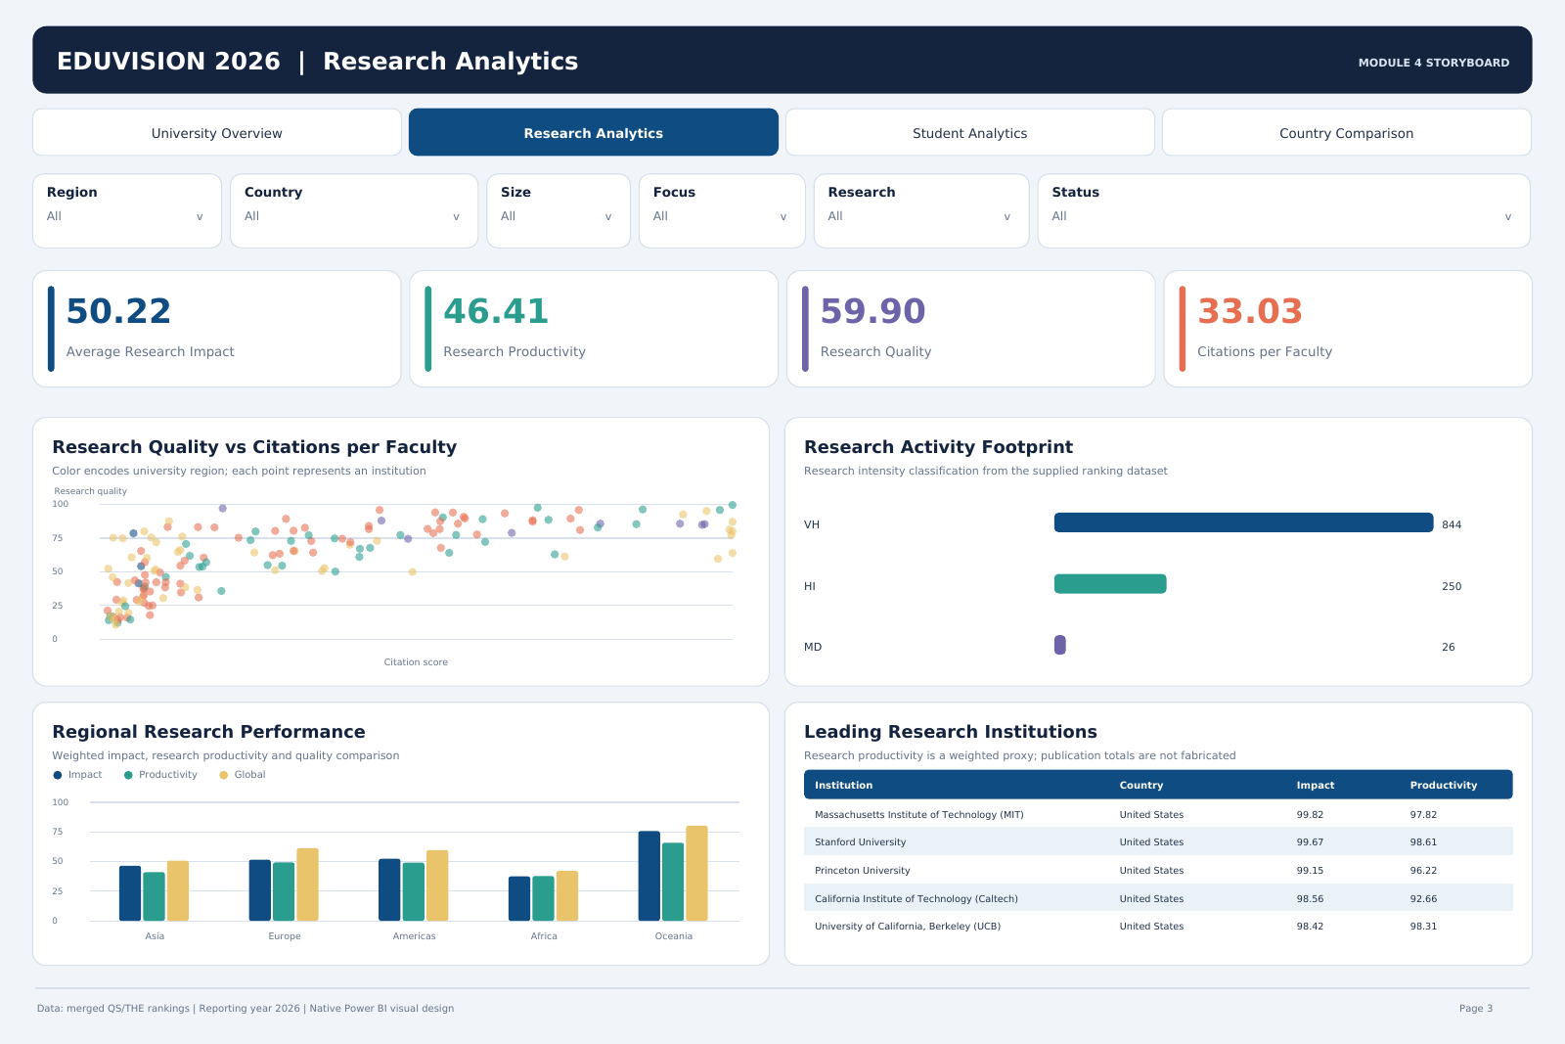
Figure 2. Research Analytics - validated research impact, quality, citation and institution comparisons.

9. Filter, Navigation and Cross-Interaction Testing
- Each page contains Region, Country, Size, Focus, Research Activity and Institution Status slicers.
- Slicer projections are active and use model fields that exist in the Universities table.
- KPI cards, graphs, matrices and maps on the same page respond to the selected filter context.
- Country Comparison supports multiple countries for direct benchmarking.
- Selecting a chart mark uses Power BI's native cross-filtering behaviour because the data projections remain active.
- Every page contains one native page navigator. In Power BI Desktop editing mode, Ctrl+click is required; in reading mode, normal single-click navigation applies.
- Clearing slicer selections returns the page to the baseline 1,120-university context.

10. Standard Map Testing
The approved release uses Power BI's standard map visual, not Azure Maps. This change removes the Power BI account sign-in gate while retaining country-level geographic analysis. Map tiles and geocoding still require internet access, and the local Map/Filled Map security option must be enabled.
PAGE | LOCATION | LEGEND | BUBBLE SIZE | TOOLTIPS
University Overview | Country | Region | University Count | Global score, reputation and research impact
Research Analytics | Country | Region | Research Impact | Count, productivity, quality and citations
Student Analytics | Country | Region | International Students % | Count, population, diversity and staffing
Country Comparison | Country | Region | Global Score | Count, research, reputation and rank movement
Executive Command Center | Country | Region | Global Score | Count, research, international share and sustainability

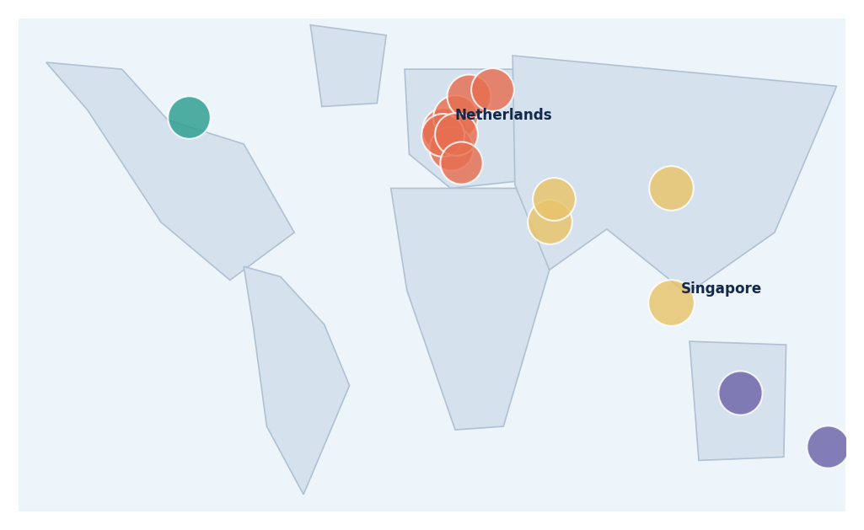
Figure 3. Standard country-level map analysis used on Research Analytics.

11. Compatibility, Performance and Reliability Controls
CONTROL | RESULT | OPERATIONAL NOTE
Latest Power BI Desktop | Supported | Open EduVision.pbip; refresh once; optionally save as PBIX.
Power BI sign-in | Not required | The release excludes Azure Maps and cloud AI visuals.
Internet | Required only for map tiles/geocoding | All non-map analytics remain available from the embedded model.
Automatic page refresh | Not supported for Import mode | Use Home > Refresh when data changes.
Portability | Passed | No machine-specific workbook path or external datasource object.
Visual definition load | Passed | 110 JSON visual definitions parse successfully.
Field binding | Passed | Every referenced field resolves to a model measure or column.
Page bounds | Passed | Maps and page content remain inside the defined page dimensions.

Runtime response time is affected by the user's computer, Power BI Desktop version and map connection. No unsupported universal timing claim is made. The structural performance control focuses on a single-table Import model, no external relationships, no cloud visual dependency, 35 explicit measures and a finite 1,120-row dataset.

12. Defect History and Regression Closure
DEFECT | ROOT CAUSE | RESOLUTION | CLOSURE EVIDENCE
Blank PBIP visuals | Unprocessed PBIP cache | Refresh-once and PBIX save workflow | UAT open/refresh tests
Blank KPI cards | Modern-card runtime binding issue | Stable card visual with Values role | 22 bound card checks
Header-only charts | Inactive numeric projections | Activated all projections | 310 active; 0 inactive
Header-only scorecards | Incorrect table binding | Pivot matrices with rows and values | Field-binding validation
Azure Map sign-in | Azure visual account gate | Five standard maps | No azureMap type remains
Navigation confusion | Ctrl+click required in edit mode | Visible instruction and user guide | UAT navigation scenarios
Local Excel path risk | Machine-specific File.Contents | Embedded compressed Import data | Portability tests

REGRESSION RESULT
Every closed defect is represented by at least one current regression test. The final release contains zero open critical defects.

13. User Acceptance Testing and Sign-Off
Twenty UAT scenarios cover opening, refreshing, KPI visibility, page-level analytics, map rendering, filters, cross-filtering, navigation, PBIX saving and reopening. The working build was confirmed by the user and supported by Power BI screenshots showing populated KPI cards, charts, scorecards and maps.
UAT AREA | ACCEPTED RESULT
University Overview | 1,120; 93; 57.1; 100.0 KPI baseline visible
Research Analytics | 50.2; 46.4; 59.9; 33.0 KPI baseline visible
Student Analytics | 25K; 17.3; 14.6%; 36.6 KPI baseline visible
Country Comparison | 93; 1,120; 389 improved; 428 declined visible
Maps | Standard maps visible with Country and Region roles
PBIX workflow | Refreshed report saved and reopened as PBIX

The QA workbook includes a formal sign-off sheet with project-owner, reviewer, date, decision, signature and comments fields. Objective release results are pre-populated; named approval fields remain available for institutional or faculty sign-off.

14. Risk Assessment and Final Release Gate
RISK | CONTROL | RESIDUAL
Map tiles unavailable | Document internet dependency; retain non-map analytics | Low
Map option disabled | Enable Map/Filled Map under Global Security and restart | Low
PBIP first refresh omitted | START_HERE launcher and first-open procedure | Low
Old PBIX opened | Approved release name and SHA-256 | Low
Source schema changes | Re-run validator and field-binding checks | Medium
2026 snapshot misread | Prominent reporting-year limitation | Low
Productivity misread as publications | Proxy formula and limitation control | Low
Power BI runtime update | Regression-test after Desktop upgrades | Medium

FINAL GATE
The release gate is APPROVED: 300 passed, 0 failed, 100.0% pass rate, and zero critical open defects.

Appendix A. How to Re-run the Validation
- Install the Python dependencies listed in the project environment.
- Open a terminal in the Milestone 4 package root.
- Run: python MODULE_07_QA_TESTING/automation/validate_milestone4.py
- Run: python -m unittest MODULE_07_QA_TESTING/automation/test_milestone4.py -v
- Review module7_validation.json, test_results.csv and dashboard_inventory.json under the evidence folder.
- Before final packaging, run the validator again with --include-deliverables.

Appendix B. Evidence Index
EVIDENCE | PURPOSE
EduVision_Module_7_QA_Master.xlsx | Detailed traceability, test register, UAT, defects, risks and sign-off
module7_validation.json | Machine-readable release summary and all test rows
test_results.csv | Flat test-case evidence for audit or filtering
dashboard_inventory.json | Page and visual contract inventory
data_dictionary.json | Field-level metadata for all 50 final dataset fields
validate_milestone4.py | Reproducible validation program
test_milestone4.py | Regression unittest suite

